- BASIC OF NETWORK
- A network is defined as a group of two or more computer systems linked together. There
are many types of computer networks, including the following:
- local-area networks (LANs): The computers are geographically close together (that is, in thesame building).
- wide-area networks (WANs): The computers are farther apart and are connected by telephone lines or radio waves.
- metropolitan-area networks MANs): A data network designed for a town or city.

- Network Characteristics
- In addition to these types, the following characteristics are also used to categorize different types of networks:
- topology : The geometric arrangement of a computer system. Common topologies include a bus, star, and ring. See the Network topology diagrams in the Quick Reference section of Webopedia.
- protocol : The protocol defines a common set of rules and signals that computers on the network use to communicate. One of the most popular protocols for LANs is called Ethernet. Another popular LAN protocol for PCs is the IBM token-ring network .
- architecture : Networks can be broadly classified as using either a peer-to-peer or client/server architecture. Computers on a network are sometimes called nodes. Computers and devices that allocate resources for a network are called servers.

- TCP/IP NETWORKING
-  TCP/IP is an abbreviation for Transmission Control Protocol / Internet Protocol.
- It is a set of protocols that define how two or more computers can communicate with each other.
- The protocol is effectively a set of rules that describe how the data is passed between the computers.
- It is an open standard so can be implemented on any computer with the appropriate physical attributes.
- Within the TCP/IP networking protocol there are lots more protocols.
- These provide different functionality important to the exchange of data over the networks.
- These can be integral to the operation of the networking, such as the Domain Name System or could be an application that uses the network such as E-mail (both of these are discussed in further detail later).
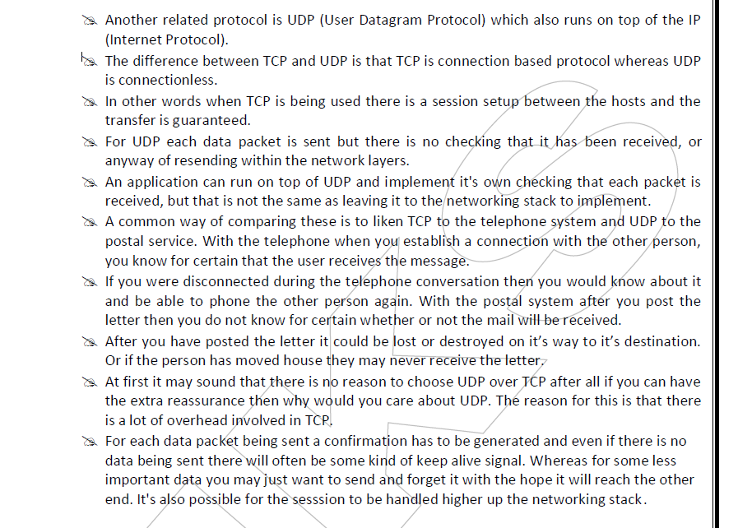
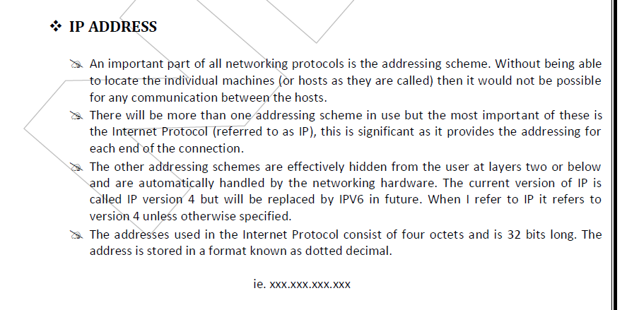
- where xxx is a number between 0 and 255.
- So an example IP address may be: 192.168.3.27
- Most users however would not actually need to use the IP address. Instead they would refer to the computer using it’s host name.
- The IP address is obtained from the host name using the "Domain Name System" (DNS). There is no actual relationship between the hostname and the IP address instead this uses a lookup table.
- The Domain Name Service will be discussed later.
- The IP addressing scheme provides 232 possible addresses, which could potentially have over 4.2 thousand million individual addresses.
- The problem with this however is that trying to locate each one of those addresses individual over the Internet would be an enormous task. So instead the address is split into a network and a host portion. The idea being that different organisations can be assigned a network which can have between 256 and 16.7 million addresses available for hosts.
- The address range now allows up to 3.7 thousand million hosts on 2.1 million networks.
- To accommodate for different sized organisations which require a different number of host addresses, the addresses are split into different network classes.
- There are 5 different classes however only 3 are commonly used.
- Class A - These are for large organisations. The network portion is 8 bits long and begins with binary 0. There are 126 possible networks each with up to 16.7 million hosts.
- Class B - These are for medium sized organisations. The network portion is 16 bits long and starts with binary 10. There are 16 thousand networks each with up to 65 thousand hosts. In reality the definition of a medium sized organisation would be a very large company.
- Class C - These are for smaller organisations. The network portion is 24 bits long and begins with binary 110. There are 200 thousand possible networks each with up to 254 hosts. In reality even these are quite large, so are often split further (see later).
- Class D - These are allocated for multicast although are rarely used. The addresses begin with binary 1110.
- Class E - These are experimental. The addresses begin with binary 1111.
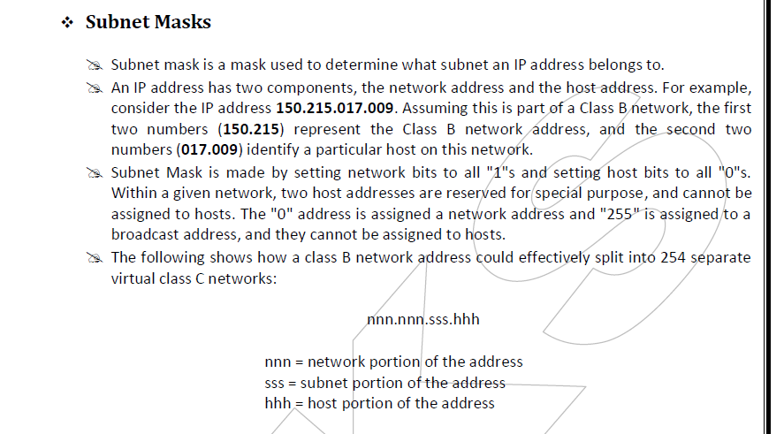
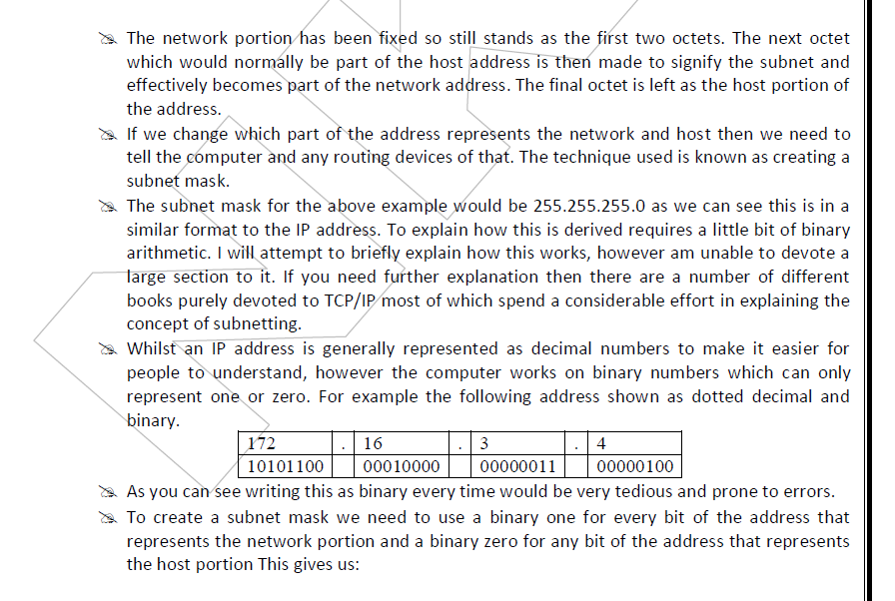
11111111 11111111 11111111 00000000
- We convert this to decimal to make it easier to read and it gives us a subnet mask of 255 . 255 . 255 . 0
- Using simple binary arithmetic the computer can use the subnet mask to convert the IP address into it’s network and host portion.
- It would use a binary AND to get the network portion.
- To get the host portion the subnet mask is inverted (NOT function) and then AND’d against the IP address.
- Just to confuse matters further some equipment (e.g. Cisco routers) use a different notation to represent the subnet mask.
- The would count in the number of '1' bits and give that as the subnet mask number. So in this example the subnet mask would be represented as /24. This is referred to as the CIDR notation.
- The example above showed the subnet mask on a octet boundary however it is more common to see a subnet mask within an octet.
- For example the subnet mask 255.255.255.248 might be used to split a class C network address into 30 subtends each with 6 hosts.
- The expanded mask would be:
11111111 11111111 11111111 11111000
- Taking only the last eight bits the host portion is
- 11111 This potentially can have 32 subtends excluding reserved addresses (all ones and all zeros) gives 30 valid addresses.
- The network portion is 000 This potentially can have 8 hosts excluding reserved addresses (all ones and all zeros) gives 6 valid addresses.
- The subtends are given a number which is when all the host portion are zero. All the rest of the addresses are valid until the part where all the host bits are ones which is the broadcast address for that subnet.
- Looking at only the last octet the following table shows how some of the address will be made up.
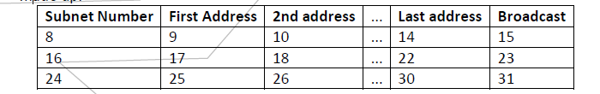
- To try and understand this better convert the values in binary and then identify the host and network portions of the address.
- Whilst I have excluded the 0 address it is sometimes possible to actually use this. For this you may have to ensure that your routers support this and that the feature is turned on.
- It is however not recommended.
- A alternative subnet mask could be 255.255.255.224 which would give 6 valid subs each having a maximum of 30 hosts (this could be useful for splitting up a smaller company which might have 6 different LAN segments with up to 30 machines on each).
- You may find it a useful exercise to try and calculate these values for yourself.
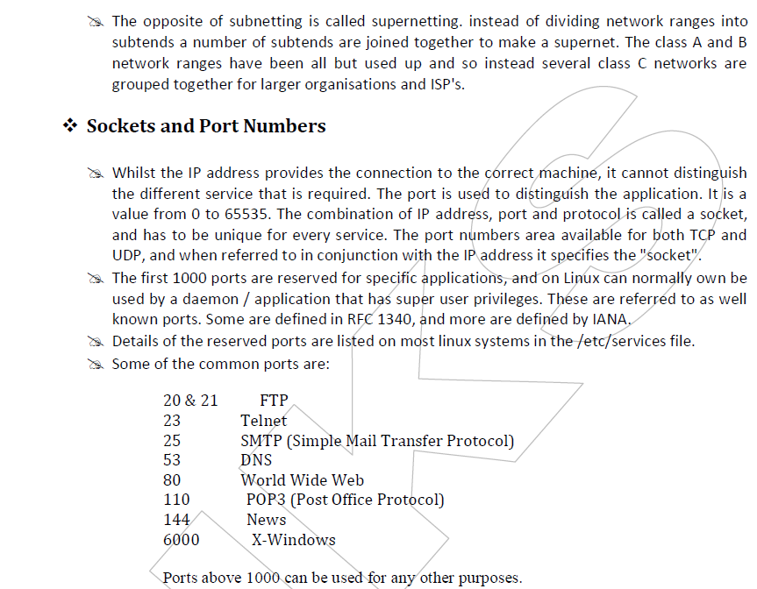
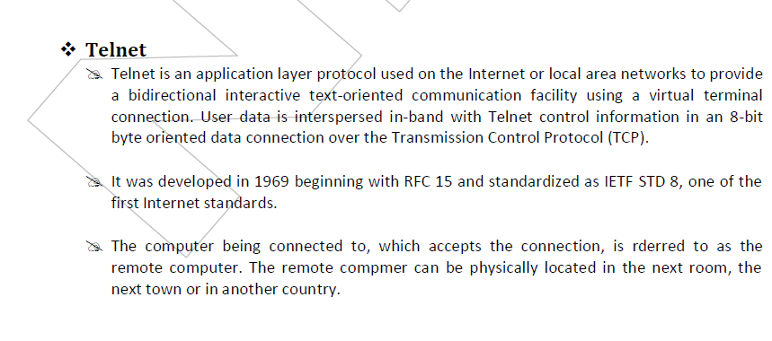
- The network terminal protocol (TELNET) allows a user to log in on any other computer on the network.
- We can start a remote session by specifying a computer to connect to. From that time until we finish the session, anything we type is sent to the other computer.
- The Telnet program runs on the computer and connects your PC to a server on the network. We can then enter commands through the Telnet program and they will be executed as if we were entering them directly on the server console. This enables we to control the server and communicate with other servers on the network. To start a Telnet session, we must log in to a server by entering a valid username and password. Telnet is a common way to remotely control Web servers.
- The term telnet also refers to software which implements the client part of the protocol.
- TELNET clients have been available on most Unix systems for many years and are available virtually for all platforms. Most network equipment and OSs with a TCP/IP stack support some kind of TELNET service server for their remote configuration including ones based on Windows NT. TELNET is a client server protocol, based on a reliable connection oriented transport. Typically this protocol used to establish a connection to TCP port 23, where a getty-equivalent program (telnetd) is listening, although TELNET predates.
- Telnet was developed in 1969 to aid in remote connectivity between computers over a network. Telnet can connect to a remote machine that on a network and is port listening.

- Most common ports to which one can connect to through telnet are:
Port 21 - File Transfer Protocol
Port 22 - SSH Remote Login Protocol
Port 23 - Telnet Server
Port 25 - Simple Mail Transfer Protocol (SMTP)
Port 53 - Domain Name Server (DNS)
Port 69 - Trivial File Transfer Protocol (TFTP)
Port 70 – Gopher
Port 80 - Hyper Text Transfer Protocol (HTTP)
Port 110 - Post Office Protocol 3 (POP3)
-  Telnet can be used to connect to virtually any machine that listens on ports. In other words, you can connect to any machine that has certain ports open.
- Once connected to a machine, you need to issue UNIX based commands to interact with the remote service.
- For example, a user don't need to login, check and send mails only through his e-mail service provider's interface but this can be achieved using simple telnet commands.
- It is because of this reason that many hackers can send spoofed emails or access information such as which services are running on the remote machine. This is also called banner grabbing or daemon tracking.
- Black hat hackers can also use telnet to sniff network packets which might contain sensitive information such as usernames and passwords.
- This is achieved by using telnet and network utilities such as TCP dump and wire shark.
- Telnet client and server functionality comes built-in in most operating systems. However, there are several third-party applications like putty client that enable remote connectivity.
- A user can connect to a remote machine through several access modes such as raw access, SSH access, etc. SSH mode offers encryption and security and hence can prevent eavesdropping by hackers.
- This is by far the most secure way of connecting to a machine.
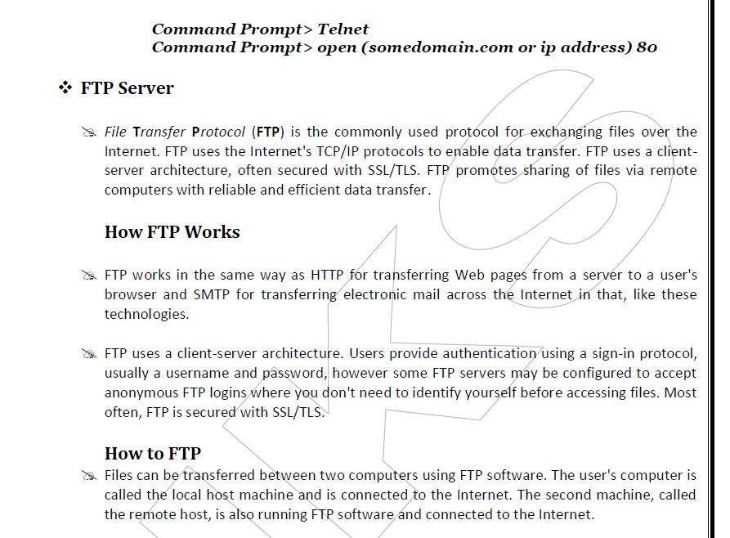
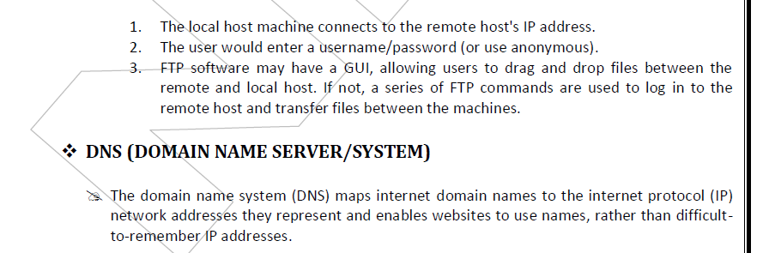

- How does DNS works ?
- DNS servers answer questions from both inside and outside their own domains. When a server receives a request from outside the domain for information about a name or address inside the domain, it provides the authoritative answer.
- When a server receives a request from inside its own domain for information about a name or address outside that domain, it passes the request out to another server -- usually one managed by its internet service provider. If that server does not know the answer or the authoritative source for the answer, it will reach out to the DNS servers for the top-level domain.
- DNS servers answer questions from both inside and outside their own domains. When a server receives a request from outside the domain for information about a name or address inside the domain, it provides the authoritative answer.
- When a server receives a request from inside its own domain for information about a name or address outside that domain, it passes the request out to another server -- usually one managed by its internet service provider. If that server does not know the answer or the authoritative source for the answer, it will reach out to the DNS servers for the top-level domain.
- NFS SERVER CONFIGURATION
- A Network File System (NFS) allows remote hosts to mount file systems over a network and interact with those file systems as though they are mounted locally.
- This enables system administrators to consolidate resources onto centralized servers on the network. You can then directly access any of the files on that remote file system. The server and client do not have to use the same operating system. The client system just needs to be running an NFS client compatible with the NFS server.
- Currently, there are three versions of NFS. NFS version 2 (NFSv2) is older and is widely supported. NFS version 3 (NFSv3) has more features, including variable size file handling and better error reporting, but is not fully compatible with NFSv2 clients. NFS version 4 (NFSv4)
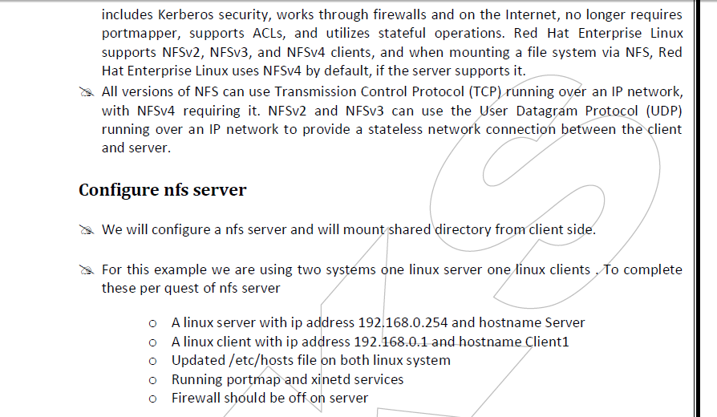
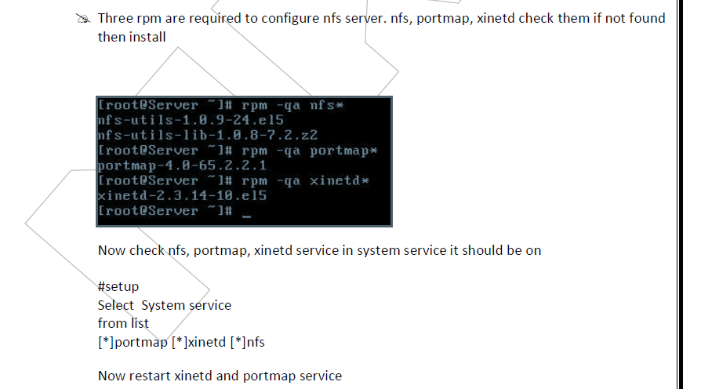

- To keep on these services after reboot on then via chkconfig command
- After reboot verify their status. It must be in running condition
- now create a /data directory and grant full permission to it
- now open /etc/exports file
- share data folder for the network of 192.168.0.254/24 with read and write access
save file with :wq and exit
- now restart the nfs service and also on it with chkconfig
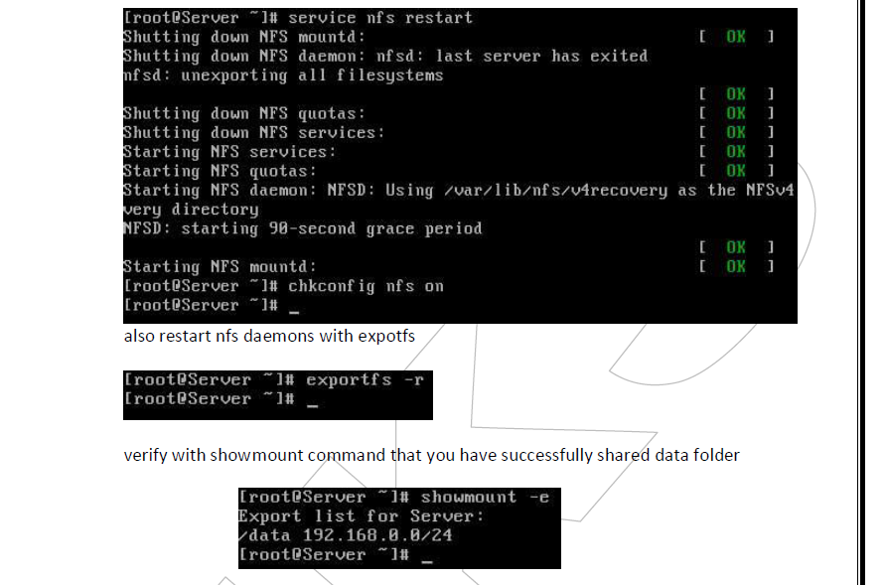
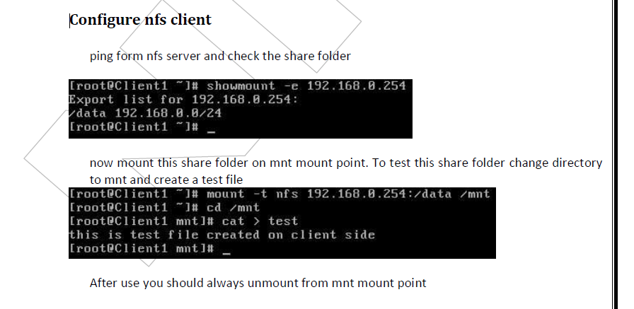
- In this way you can use shared folder. But this share folder will be available till system is up.
- It will not be available after reboot. To keep it available after reboot make its entry in fstab create a mount point, by making a directory
- now open /etc/fstab file
- make entry for nfs shared directory and define /temp to mount point
- save the with :wq and exit reboot the system with reboot - f command
#reboot -f
- after reboot check /temp directory it should show all the shared data
- Basics of Samba Server : Installation & Configuration
- Defination : "Samba is an Open Source/Free Software suite that provides seamless file and print services to SMB/CIFS clients." Samba is freely available, unlike other SMB/CIFS implementations, and allows for interoperability between Linux/Unix servers and Windowsbased clients.
OR
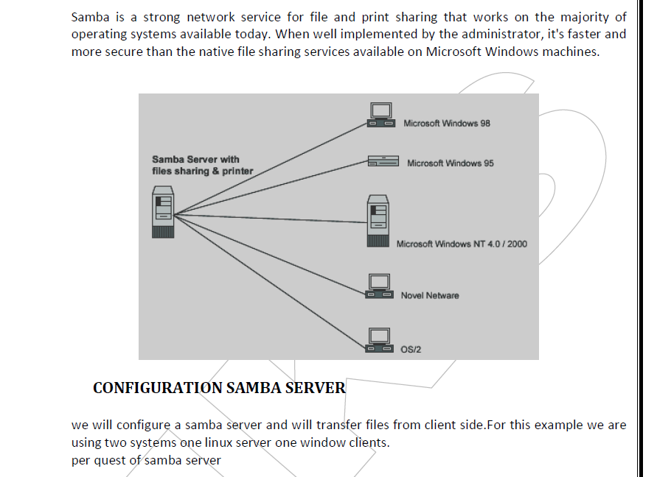
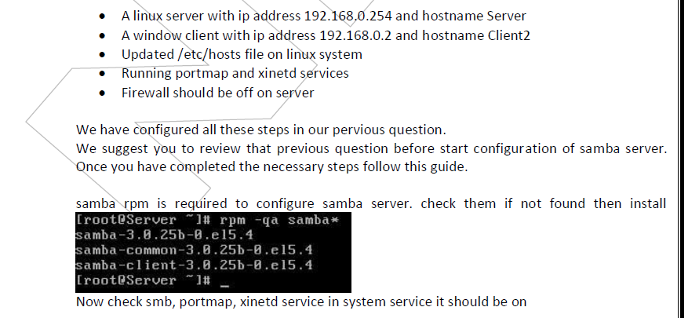

#setup Select System service from list [*]portmap [*]xinetd [*]smb

- Now restart xinetd and portmap and smb service
- To keep on these services after reboot on then via chkconfig command
- After reboot verify their status. It must be in running condition
- Create a normal user named vinita
- now create /data directory and grant it full permission
- open /etc/samba/smb.conf main samba configuration files
- By default name of workgroup is MYGROUP in smb.conf file. you can change it with desire name.
- our task is to share data folder for vinita user so go in the end of file and do editing as shown here in this image
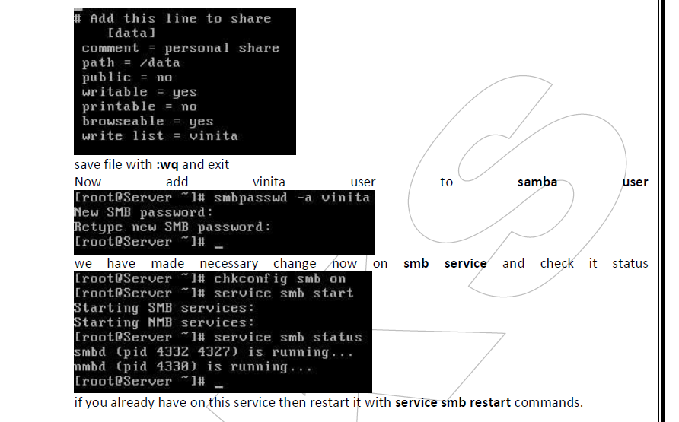
- Client configuration for samba server
- Go on windows system and ping samba, change computer name to client2 and workgroup name to MYGROUP
reboot system after changing workgroup name
- After reboot open my network place here you can see samba server [ if not see then click on view workgroup computer in right pane, if still not see then use search button from tool bar and search computer samba server form ip ]
- First try to login from user nikita she will not successes as nikita have not permission to login
- Now login from user vinita [ give the password which you set with smbpasswd command ]
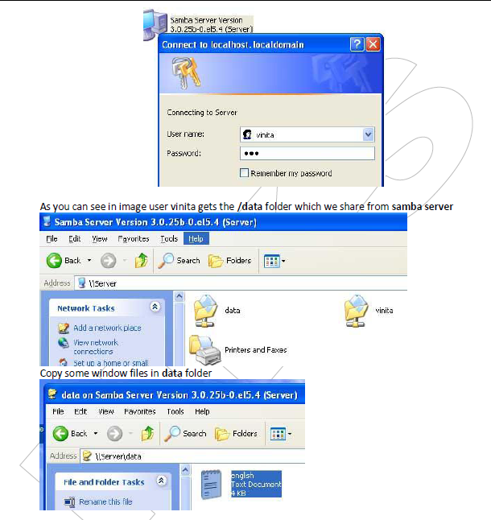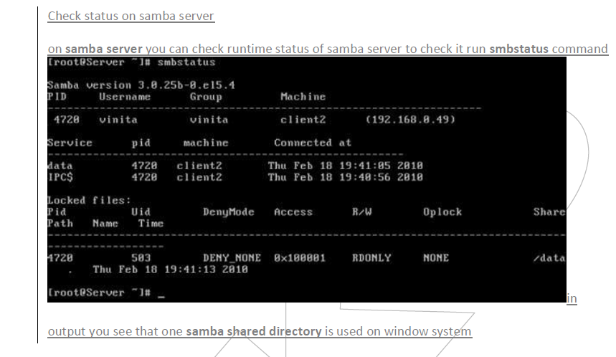
- SHARING & PRINTING WITH SAMBA?
- Samba allows client machines to share printers connected to the Samba host system, and Samba can also send Unix documents to printers shared by Windows systems
- Sending Print Jobs to Samba
- A printer shared by the Samba server shows up in the list of shares offered in the Network Neighborhood. If the printer is registered on the client machine and the client has the correct printer driver installed, the client can effortlessly send print jobs to a printer attached to a Samba server. below figure shows a Samba printer as it appears in the Network Neighborhood of a Windows client.

